# System Architecture

1. Identify the system architecture(s) that will be in use. Provide written explanation regarding your choice.

**Answer.**

The system architecture that we shall be using for our project EduLoyalty will be microservices architecture. The system architecture will be divided into set of different services that will support an API. These services will be exchanging and transforming data while interacting with each other for performing different functions.

The services will be performing different functions like managing user login and authentication, performing various computations, sending data to the user interface in order to display information at frontend.

We have taken this approach for following reasons:

* It will help us decentralize the approach to building the system as each service will be performing its own function and even if there is issue each service can be isolated, rebuilt and redeployed.
* Besides this the microservices architecture is platform agnostic that is it can be developed and deployed using different languages as tools like in frontend we will be using Javascript(React) and at backend we plan to use Django.
* Additionally, the services can be reused in different system thus for instance we shall be creating a dummy system to track user login activity we will use the same authentication service for both dummy system as well as reward point system.
* Microservices are faster and far less resource-intensive to deploy and load balance; thus for our application which will be hosted on our local machines this architecture is best suited.
* Majority consumption of services happens in REST API format for various systems; we shall be using REST API for exchanging data and processing information so as to ensure its reusability and applicability in real world environment.

1. Provide at least 2 different views of the system architecture. Provide written

explanation regarding your choice.

* Client Server Architecture view

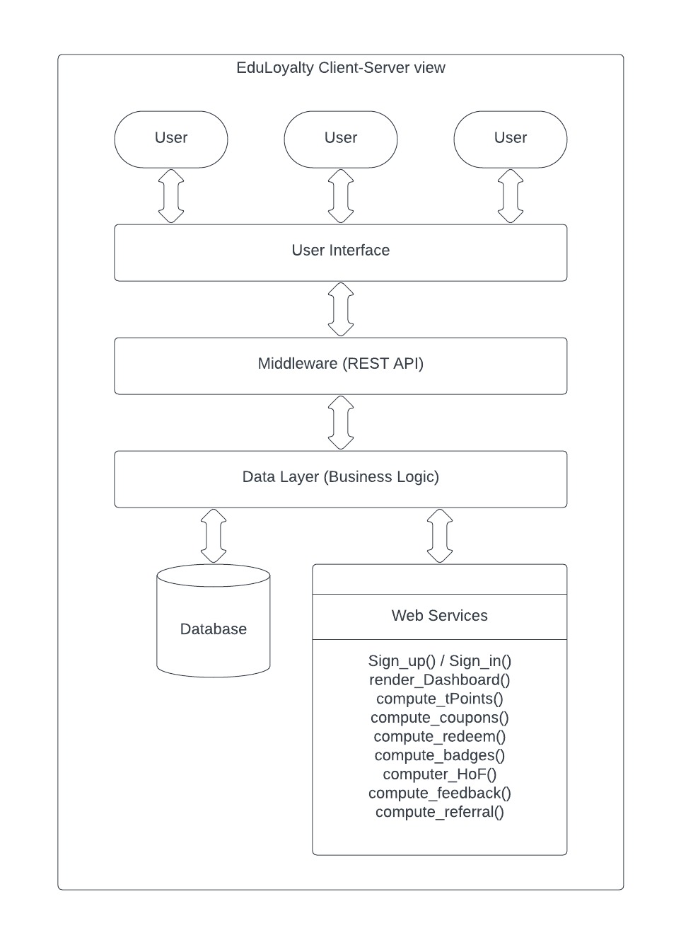

* Pipe and Filter Architecture View

